

American International University-Bangladesh (AIUB)  
Department of Computer Science  
Faculty of Science &Technology (FST)  
Spring 21 22

Section: A   
Software Quality Assurance and Testing

**Vromon – Community Based Travel Services**

A Report submitted

By

|  |  |  |
| --- | --- | --- |
| SN | Student Name | Student ID |
| 1 | EMON, FAHIM AHMED | 18-38517-2 |
| 2 | RAHMAN, MAHJABIN |  |
| 3 | TANIM, MD. IFTEKHER JALAL |  |
| 4 | PATWARY, SAKIB |  |

Under the supervision of

**ABHIJIT BHOWMIK**

Associate Professor

Special Assistant [OSA]

Faculty of Science &Technology

Software Test Plan

for

Vromon

Version 1.0 approved

Prepared by Fahim Ahmed Emon, Mahjabin Rahman, Md. Iftekher Jalal Tanim & Sakib Patwary

American International University-Bangladesh (AIUB)

19-04-2021

Table of Contents

Revision History 3

1. TEST PLAN IDENTIFIER: RS-MTP01.3 3

2. REFERENCES 3

3. INTRODUCTION 3

Background to the Problem 3

Solution to the Problem 4

4. REQUEIREMNT SPECIFICATION 4

4.1 System Features 4

4.2 System Quality Attributes 4

4.3 System Interface 5

4.4 Project Requirements 5

5. FEATURES NOT TO BE TESTED 5

6. TESTING APPROACH 5

6.1 Testing Levels 5

6.2 Test Tools 6

6.3 Meetings 6

7. TEST CASES/TEST ITEMS 6

8. ITEM PASS/FAIL CRITERIA 7

9. TEST DELIVERABLES 7

10. STAFFING AND TRAINING NEEDS 8

11. RESPONSIBILITIES 8

12. TESTING SCHEDULE 8

13. PLANNING RISKS AND CONTINGENCIES 9

14. APROVALS 9

# Revision History

|  |  |  |  |
| --- | --- | --- | --- |
| Revision | Date | Updated by | Update Comments |
| 0.1 | 2007.06.04 | Scot Robinson | First Draft |
| 0.2 | 2007.06.19 | Amit Nimse |  |
|  |  |  |  |
|  |  |  |  |
|  |  |  |  |
|  |  |  |  |
|  |  |  |  |
|  |  |  |  |
|  |  |  |  |

# TEST PLAN IDENTIFIER:RS-MTP01.3

# REFERENCES

* Software Requirement Specification (SRS) Document
* High Level Design Document
* Detail Design Document
* Low Level Design Document

# INTRODUCTION

## Background to the Problem

In this age of technological advancement, the demand for online services have increased to an extent which was never seen before. Moreover, the COVID-19 pandemic has clearly shown the advantages of moving operations online. These advantages are also applicable to the travel industry of Bangladesh. Nowadays, people are looking for travel related information on the internet, since it is the most accessible and easiest way of getting information.

There are a number of online travel startups in Bangladesh. The first software solution provider to create such a platform is PHP Holidays, which provided services like booking engines for tour operators, hotels, vacation rentals, restaurants, flights, car rentals, cruises and bus operators. Many travel agencies and travel related companies used the platform to expand their business. But PHP Holidays did not provide any information solution for the tourists.

“Vromon” is a web-based application that aims to combine the services desired by tourists as well as travel related business organizations. This application will be integrating features like information about places to travel to, classified by divisions and district names. This information can include pictures, ways to travel, possible routes to reach there, transportation and hotel facilities, possible budget requirements etc. This information will allow the customers and tourists to get a good overview as well as a cost estimation to travel to the destinations they are interested in. The users can then choose the route and book tickets, car or hotels based on their cost limits.

“Vromon” is not only for the tourists, it will also act as a hosting platform for hotel, or property owners as well as bus, car, train or airline owners. The tourists will be able to connect with the travel businesses through this platform. This platform will allow the travel business owners, as well as small asset holders to engage with tourists.

Due to the increased number of local travelers within our country, there was a rapid increase of Online Travel Agencies (OTA). But none of them present any opportunity for the tourists and the travel business owners to interact in the same platform. Most of the agencies either focus on tourist’s travel solution or provide a booking system for the business owners. Most of them do not have specific area related information and only show popular destinations, which keeps the less popular travel destinations out of focus. But none of those OTA’s provide with travel information as well as travel related services together in the same application. That is the main aim of “Vromon”, to create a one stop service for tourists as well as the travel business owners.

## Solution to the Problem

This project report showcases the feasibility, business possibilities, implementation details and estimations for a web-based application named “Vromon”. This application acts as a digital aggregation platform for the travelers and travel related business owners of Bangladesh. The report starts with the background analysis and feasibility of creating such a platform. Then the Project Specifications, Software Requirement Specifications, Software Design Description, Software Configuration Management and Software Verification and Validation are discussed sequentially. This report also discusses the Software Development Process Model which will be used and also provides with the reasoning for selection. The test cases for the purpose of Software Testing are also discussed in this report. Possible budget estimation, possible risks and the required time calculations are also included in the report. There are also some screenshots of the UI elements as Illustrative prototype.

In this section the business opportunities and scope of the project will be discussed. First, we set the goals and future prospects of the project, which can provide us with an outline of the future steps to be taken. Next, we will discuss the collected user data and analyze the market values of the features which are planned to be implemented. The market analysis will help in the understanding of the priorities of the features and feature priorities can be set accordingly. Then, the competitive position analysis will provide an idea about the position of this project in the industry and what gives us a business advantage over other companies. In the success factor section, the features which will decide the success of our project and the prospect of the people associated with the platform will be discussed. Finally, the business requirement and the overall business model of the project will be discussed.

**Vision**

* The vision of “Vromon” is to be established as a trusted travel solution provider for the travelers as well as the traveling related business owners of Bangladesh.

**Mission**

* The mission of this platform is to provide traveling related information and a one-stop service for the travelers and a platform for the business owners to reach customers easily.

**Goals**

* Provide centralized information for all districts of Bangladesh.
* Provide tourists with travel related services like transportation, ticket and hotel booking, etc.
* Provide traveling related business owners with a platform to reach their customers.

**Success Factors**

* A well-established user-base, which is already available, since there is a huge number of local travelers and travel related business owners in Bangladesh.
* Integration of district-wise travel destinations’ information.
* Availability of different travel related services like transportation, ticket and hotel booking etc.
* Easy to create online business presence for both small and large travel business owners

Easy to use User interface.

# REQUEIREMNT SPECIFICATION

## System Features

1. **App login and Signup**

**Functional Requirements:**

* 1. The application will have three types of users (Tourists, Business Owners, Admin)
  2. Users will be able to login to the application with valid email and password. The user type will be determined automatically.
  3. If the email or password is incorrect, the user will be prompted to try again.
  4. Users will be prompted to register a new account in the home page and the sign in page.
  5. When a user will register, an email will be sent to their email for account verification and confirmation.
  6. There will be a password recovery system through email.
  7. During registration, Business owners need to provide their E-Trade License and E-TIN number as well as a copy of the picture of the Trade license.
  8. Users can use the “remember me” functionality for faster login procedures.
  9. Tourists will be prompted for premium subscription during registration.

**Priority level:** High

**Precondition(s):** User email and password needs to be valid

**Cross-reference:** None

1. **Tourists Features**

**Functional requirements**

* 1. Tourists should be able to browse the travel destinations based on districts.
  2. Tourists should be able to select routes to the destination and method of transport.
  3. Tourists should be able to book hotels and/or tickets based on the destination.
  4. Tourists should be able to subscribe to premium membership
  5. Tourists should be able to select payment methods.

**Priority level:** High

**Precondition(s):** User must be logged in

**Cross-reference: <**Billing and Payment**>**

1. **Business Owner Features**

**Functional requirements**

* 1. Business Owners will be able to add their business(s).
  2. Business owners will be able to add details and pricing for their business(s).
  3. Business owners should be able to choose payment methods.
  4. Business owners will be able to pay their due to the application.

**Priority level:** High

**Precondition(s):** User must be logged in

**Cross-reference: <**Billing and Payment**>**

1. **Administrative Team Member Features**

**Functional requirements**

* 1. Admins will be able to check user information if necessary.
  2. Admins will be able to verify the validity and license of the businesses of the business owners.
  3. Admins will be able to verify the validity and license of the businesses of the business owners.
  4. Admin s will be able to look into the issues sent as support tickets and try to solve the problems with coordination with the support team.

**Priority level:** High

**Precondition(s):** User must be logged in

**Cross-reference: <**System Features**>**

1. **Destination and Search Functionality**

**Functional requirements**

* 1. Tourists will be suggested the most popular travel destination.
  2. Tourists will be able to search by destination name or district name.
  3. Top travel destinations of the searched districts will be displayed after searching.
  4. Tourists can add destinations as their favorites.

**Priority level:** High

**Precondition(s):** None

**Cross-reference: <**System Features**>**

1. **Booking Functionality**

**Functional requirements**

* 1. Tourists should be able to book flight, train, bus tickets or hotels.
  2. The business owner running the booked business will be notified.
  3. Booking options can be sorted or constrained by the tourists based on cost.
  4. Tourists should be able to cancel their booking if necessary.
  5. No advanced payment is necessary for booking.

**Priority level:** High

**Precondition(s):** User must be logged in

**Cross-reference: <**System Features**>,<**Billing and Payment**><**

1. **System Features**

**Functional requirements**

* 1. The application system will analyze user data and show recommended travel destinations based on the information.
  2. System should ensure that the offers shown are relevant to the tourists.
  3. The system will provide a faster response by caching frequently used data.
  4. System should be able to show push notifications about bookings to the business owners.
  5. Systems should be able to show the last visited destinations and history to the tourists.
  6. System will offer regular discounts to subscribed members.

**Priority level:** High

**Precondition(s):** Some functionalities will require subscription

**Cross-reference: <**Billing and Payment**>,<**Destination and search functionality**>**

1. **Billing and Payment Functionality**

**Functional requirements**

* 1. Tourists and business owners should be able to add payment methods (Credit card/ cash/ bkash).
  2. The system will be updating payment status in real time.
  3. Confirmation email for payments will be sent with a receipt.

**Priority level:** High

**Precondition(s):** User must be logged in

**Cross-reference:** None

1. **Sign out Functionality**

**Functional requirements**

* 1. Users should be able to sign out whenever they want.
  2. Users should be able to sign out of all devices/browsers in which they are logged in

**Priority level:** High

**Precondition(s):** User must be logged in

**Cross-reference:** None

## System Quality Attributes

* List down the quality attributes that describes how well the system should perform.
* Example:  
  Usability: *A trained user shall be able to submit a complete request for a chemical selected from a vendor catalog in an average of four and a maximum of six minutes.*

## System Interface

**Login page**

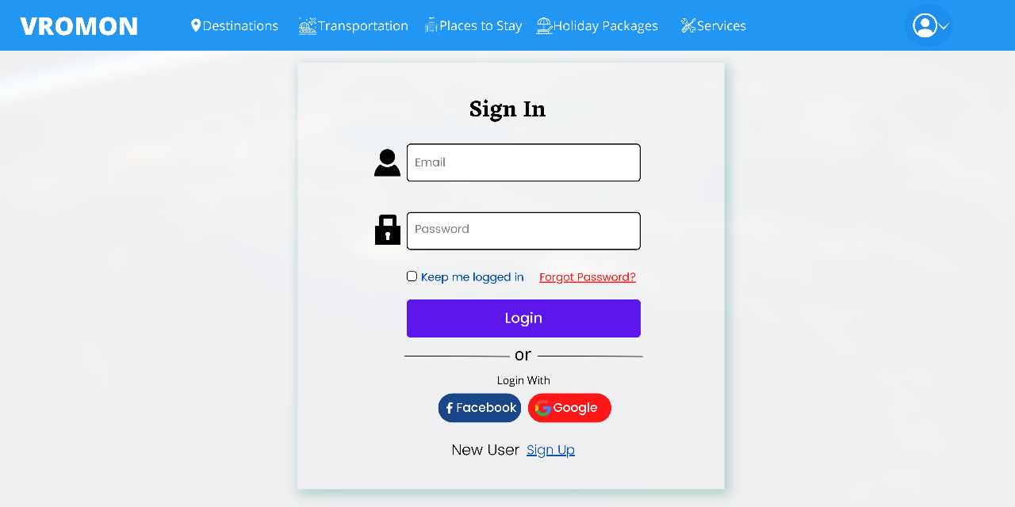

**Destination Search**

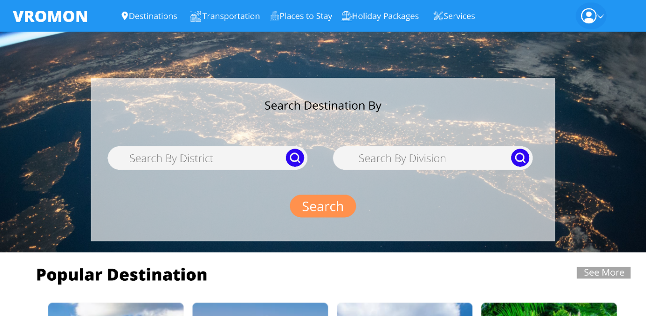

**Popular Destination**

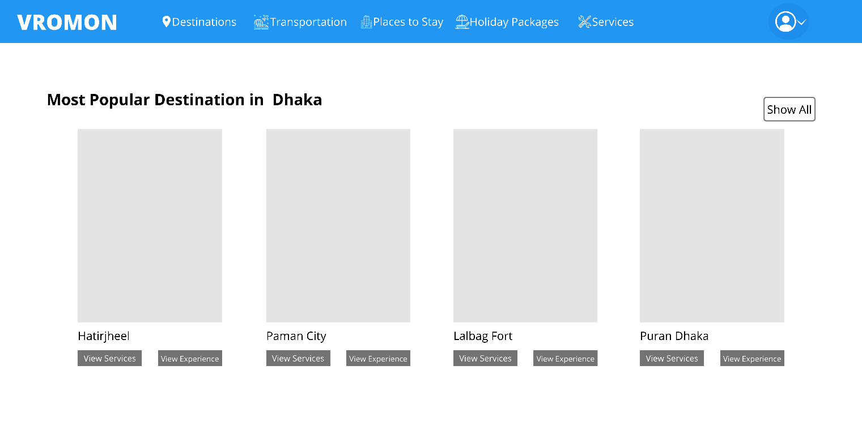

**Transportation Search**

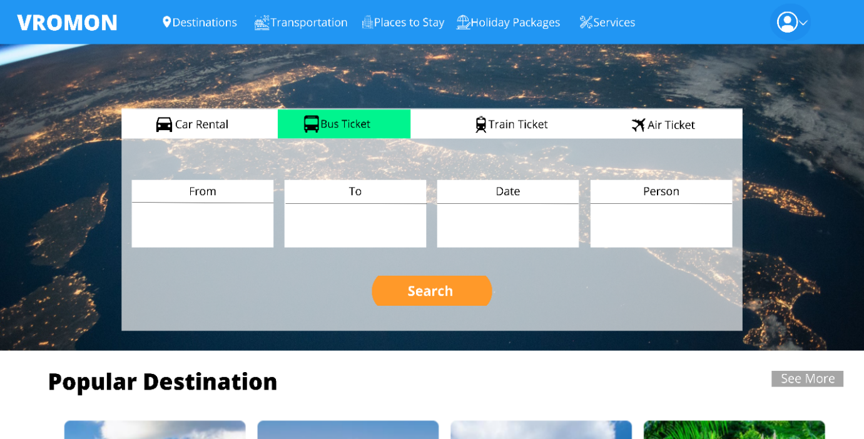

**Accommodation Search**

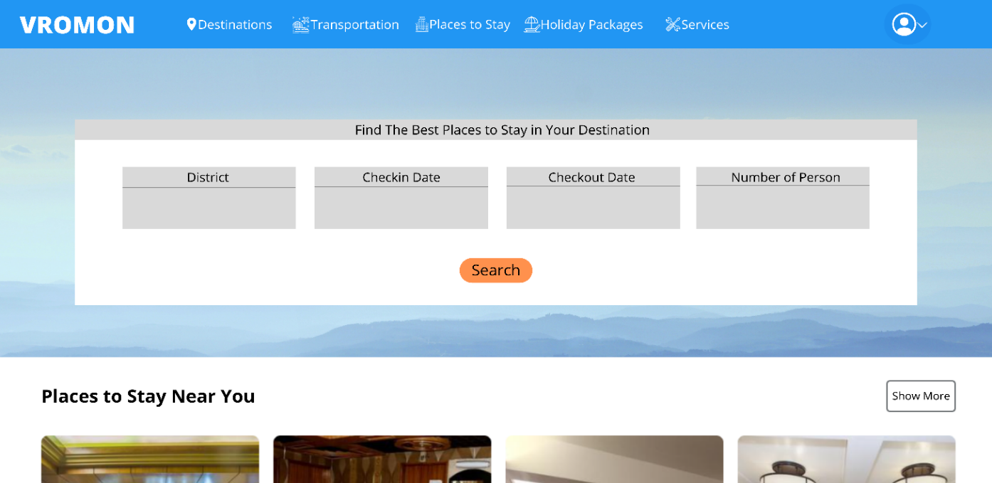

**Profile Page**

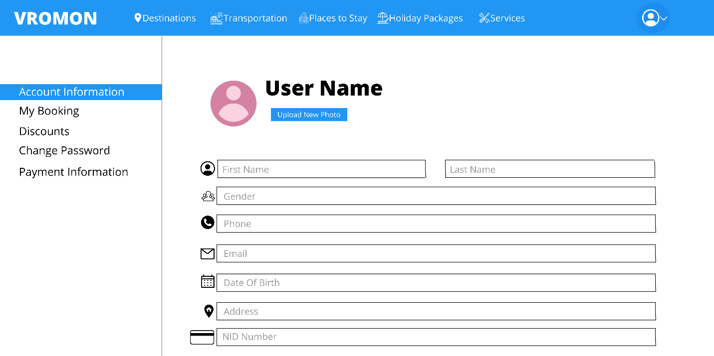

## Project Requirements

* A working solution should be ready by 3 months.
* The website should be responsive & well designed.
* Developers are preferred to use visual studio code for code editing, but can use other editors.
* Git will be used for default version control system and code managing tool.
* Unit testing will be completed using Selenium.
* Illustrative prototype will be done using Canva.
* Estimated budget for the project is 9876000 BDT.

# FEATURES NOT TO BE TESTED

The following is a list of the areas that will not be specifically addressed. All testing in these areas will be indirect as a result of other testing efforts. For example:

* Support for Logging out of multiple devices.
* Device recognition and verification for future logins without password.

# TESTING APPROACH

## Testing Levels

* The testing for the SMS project will consist of Unit, System/Integration (combined) and Acceptance test levels. It is hoped that there will be at least one full time independent test person for system/integration testing. However, with the budget constraints and timeline established; most testing will be done by the test manager with the development teams’ participation.
* UNIT Testing will be done by the developer and will be approved by the development team leader. Proof of unit testing (test case list, sample output, data printouts, defect information) must be provided by the programmer to the team leader before unit testing will be accepted and passed on to the test person. All unit test information will also be provided to the test person.
* SYSTEM/INTEGRATION Testing will be performed by the test manager and development team leader with assistance from the individual developers as required. No specific test tools are available for this project. Programs will enter into System/Integration test after all critical defects have been corrected. A program may have up to two Major defects as long as they do not impede testing of the program (I.E. there is a work around for the error).
* ACCEPTANCE Testing will be performed by the actual end users with the assistance of the test manager and development team leader. The acceptance test will be done in parallel with the existing manual ZIP/FAX process for a period of one month after completion of the System/Integration test process.

## Test Tools

The only test tools to be used are the standard AS/400 provided utilities and commands.

* The Program Development Manager (PDM) will be used as the source version configuration management tool in conjunction with the in-house check-in/check-out control utility. The check-in/out utility is part of each developer’s standard AS/400 access menu.
* The initial prototypes for the new screens will be developed using the AS/400 Screen Design Aid (SDA). The initial layout and general content of the screens will be shown to the sales administration staff prior to proceeding with testing and development of the screens.
* Must put few screenshots of using the automated testing tool you have practiced.

## Meetings

The test team will meet once every two weeks to evaluate progress to date and to identify error trends and problems as early as possible. The test team leader will meet with development and the project manager once every two weeks as well. These two meetings will be scheduled on different weeks. Additional meetings can be called as required for emergency situations.

# TEST CASES/TEST ITEMS

|  |  |  |  |  |  |
| --- | --- | --- | --- | --- | --- |
| Project Name: | | | Test Designed by: | | |
| Test Case ID: FR_1 | | | Test Designed date: | | |
| Test Priority (Low, Medium, High): Medium | | | Test Executed by: | | |
| Module Name: Login Session | | | Test Execution date: | | |
| Test Title: verify login with valid username and password | | |  | | |
| Description: Test website login page | | |  | | |
| Precondition (If any): User must have valid username and password | | | | | |
| Test Steps | Test Data | Expected Results | | Actual Results | Status (Pass/Fail) |
| 1. Go to the website 2. Enter username 3. Enter password 4. Click submit | Username: 99999999999  Password: 321 | User should login into the application | | As expected, | Pass |
| Post Condition: User is validated with database and successfully login to account. The account session details are logged in the database. | | | | | |

# ITEM PASS/FAIL CRITERIA

The test process will be completed once the initial set of distributors have successfully sent in reassigned sales data for a period of one month and the new EDI data balances with the old ZIP/FAX data received in parallel. When the sales administration staff is satisfied that the data is correct the initial set of distributors will be set to active and all parallel stopped for those accounts.

# TEST DELIVERABLES

* Acceptance test plan
* System/Integration test plan
* Unit test plans/turnover documentation
* Screen prototypes
* Report mock-ups
* Defect/Incident reports and summaries
* Test logs and turnover reports
* Fixed bug report

# STAFFING AND TRAINING NEEDS

It is preferred that there will be at least one (1) full time tester assigned to the project for the system/integration and acceptance testing phases of the project. This will require assignment of a person part time at the beginning of the project to participate in reviews etc... and approximately four months into the project they would be assigned full time. If a separate test person is not available the project manager/test manager will assume this role. In order to provide complete and proper testing the following areas need to be addressed in terms of training.

* The developers and tester(s) will need to be trained on the basic operations of the EDI interface. Prior to final acceptance of the project the operations staff will also require complete training on the EDI communications process.
* The sales administration staff will require training on the new screens and reports.

# RESPONSIBILITIES

[WILL BE ADDED]

# TESTING SCHEDULE

Time has been allocated within the project plan for the following testing activities. The specific dates and times for each activity are defined in the project plan timeline. The persons required for each process are detailed in the project timeline and plan as well. Coordination of the personnel required for each task, test team, development team, management and customer will be handled by the project manager in conjunction with the development and test team leaders.

[SCHEDULE SS WILL BE ADDED]

# PLANNING RISKS AND CONTINGENCIES

* Limited Reassigned Sales staff. The Reassigned Sales administration staff currently has two positions unfilled. As a result of this staff shortage there may be delays in getting staff to review appropriate documents and to participate in the Acceptance test process. Should client staff become a problem, the appropriate dates for reviews and acceptance testing will slip accordingly. No attempt will be made to bypass any part of the review and testing processes.

|  |  |  |  |  |
| --- | --- | --- | --- | --- |
| **Risks** | **Probability** | **Impact** | **Rating** | **RMMM** |
| Project Manager Availability | 20% | 3 | Medium | R-1 |
| Schedule slips | 40% | 1 | High | R-2 |
| System goes hour | 50% | 3 | Medium | R-3 |
| Project cancelled | 40% | 4 | Low | R-4 |
| Programmers doesn’t have good experience | 30% | 3 | Medium | R-5 |
| Late delivery | 50% | 3 | Medium | R-6 |
| Customer Participation in Beta Testing | 30% | 4 | Low | R-7 |

# APROVALS

|  |  |
| --- | --- |
| Project Sponsor | Mahjabin Rahman |
| Development and Testing team | Fahim Ahmed Emon |
| Project manager | Sakib Patwary |
| Test manager | Mahjabin Rahman |
| Development team Manager | Md. Iftekher Jalal Tanim |